Project Unit 5: Database management
Think of a web application that you would like to create.
In this unit you will only create some of the functionalities as the time is very limited. Now we will focus on the database management and the web pages.
In the next unit we will add sessions.

Requirements of the project:
- Create a new database and a new user with privileges to manage only that database.
- Create at least two tables that are related through a foreign key.
- Use classes. Separate the code that accesses the database (no GUI interaction) from the code that corresponds to the GUI.
- All must be written in English.

1. Describe your application.
My application is a database manager for Formula1. It will store the attributes of drivers, teams and cars.
For that I will create three classes, one for cars, one for drivers and another for teams, each with its unique attributes.
Then, I will need a database manager class, which will be tasked with interacting with the database.
Finally, there will be a GUI from which to interact with the whole program.

2. Database design.
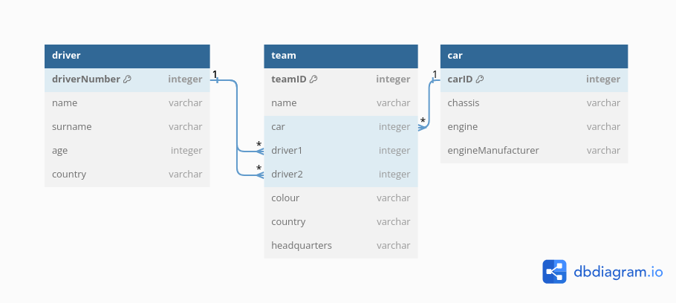

3. GUI design.

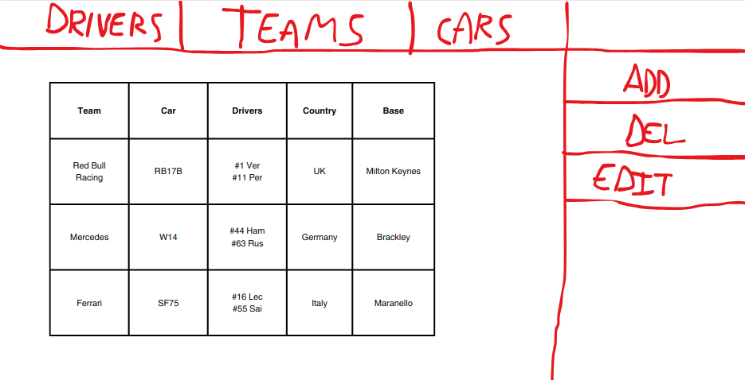
This GUI will have a top menu with three buttons that will display all of the data about them.
In my drawing the selected button is teams, therefore showing the data from each of them.
On the right there will be buttons to add, delete or modify the current displayed table, in this case, teams.

4. Create the database.
(The script is inside the .zip)

5. Create the classes that interact with the database.
(Inside the .zip as well)

6. Create the GUI.

Drivers
Display:
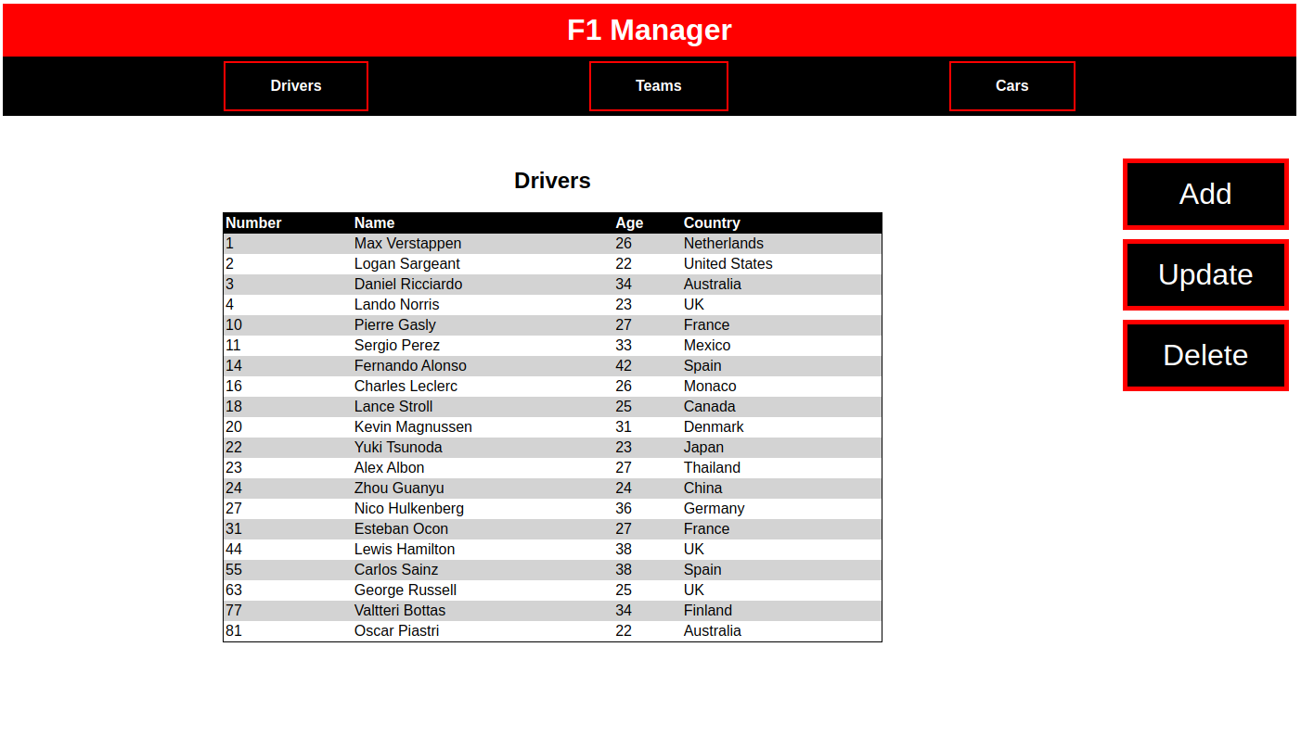
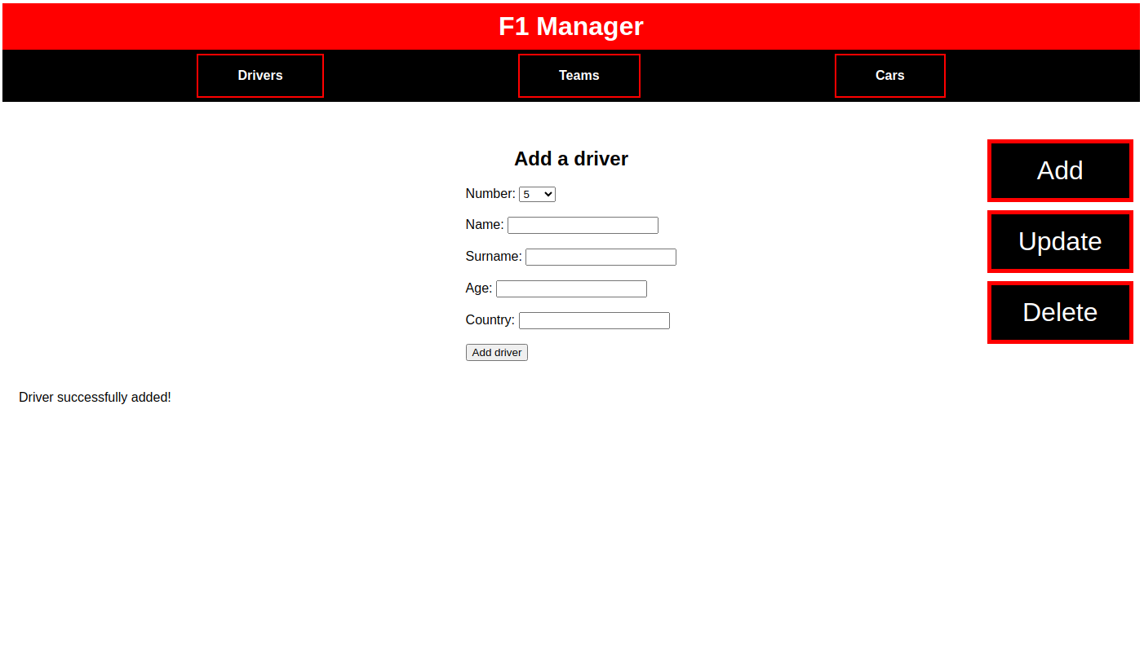
Add:
Update:
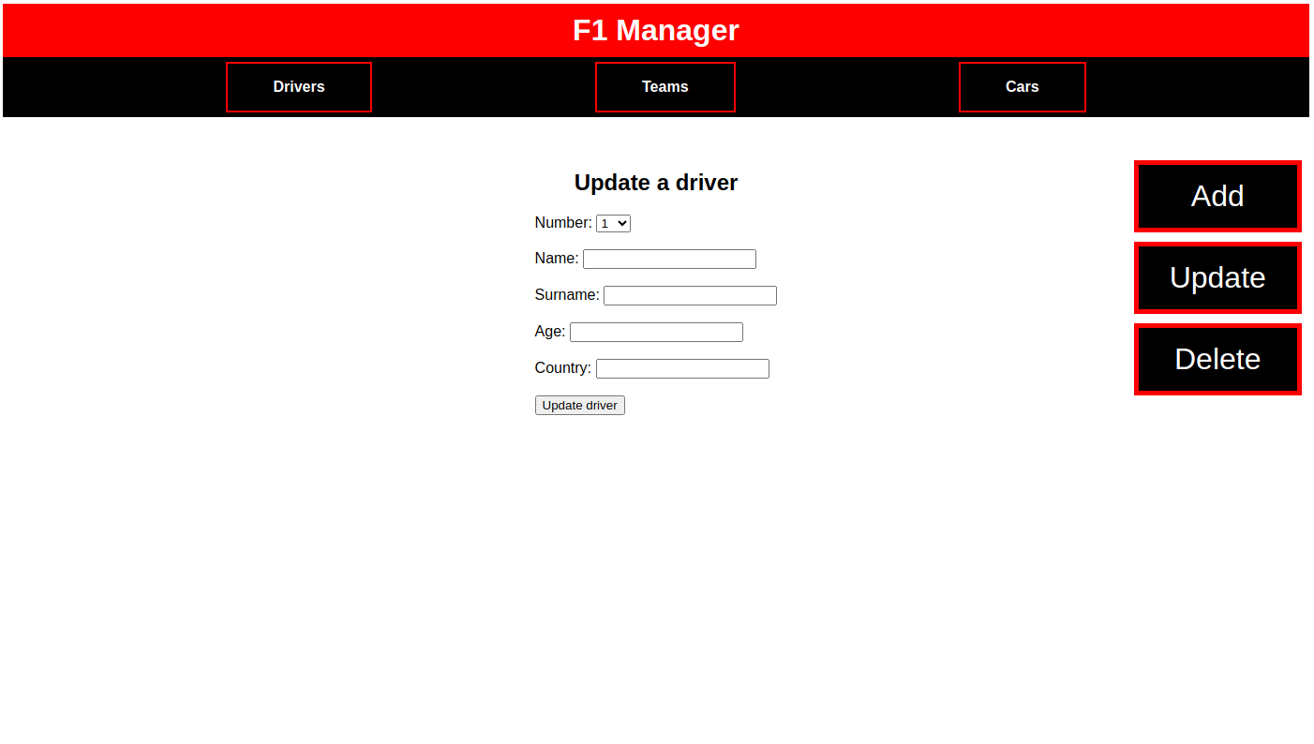
Delete:
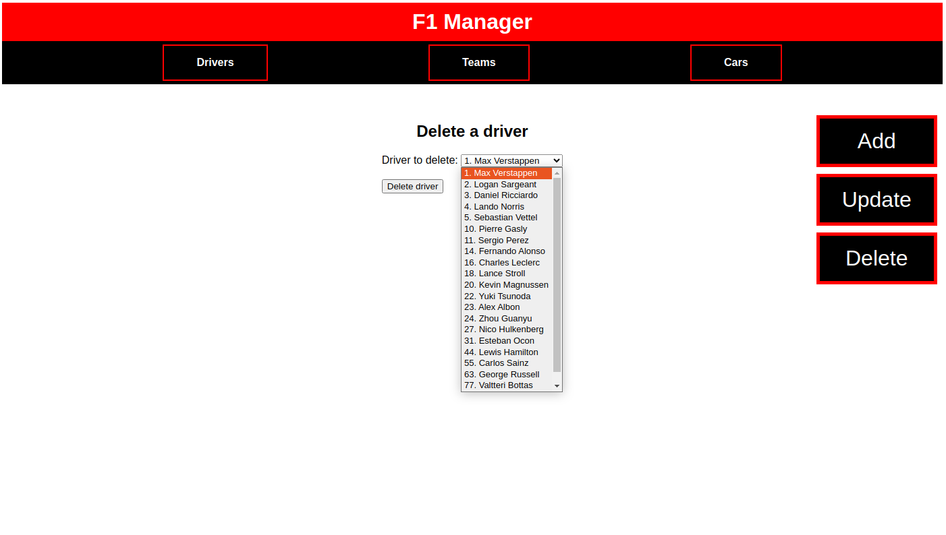

Teams
Display:
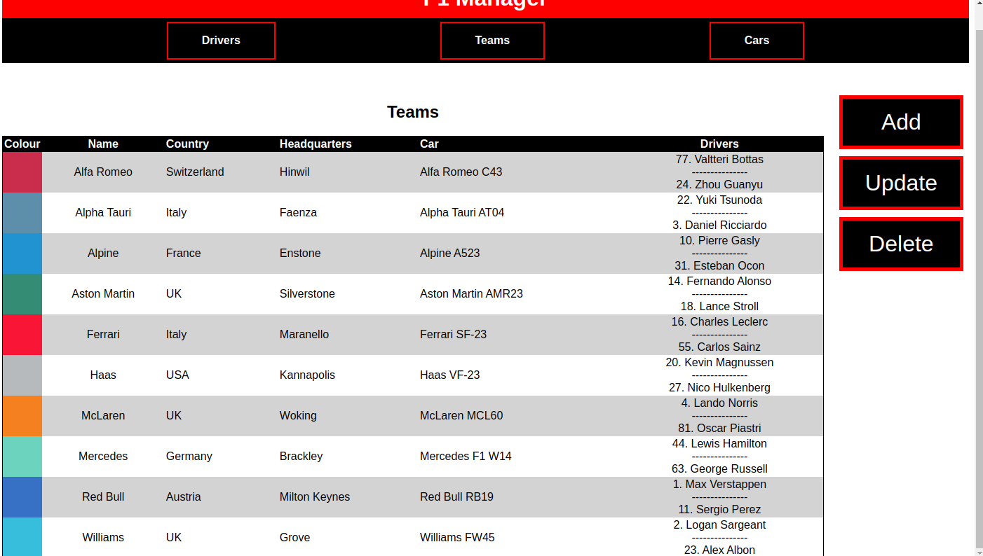
Add:
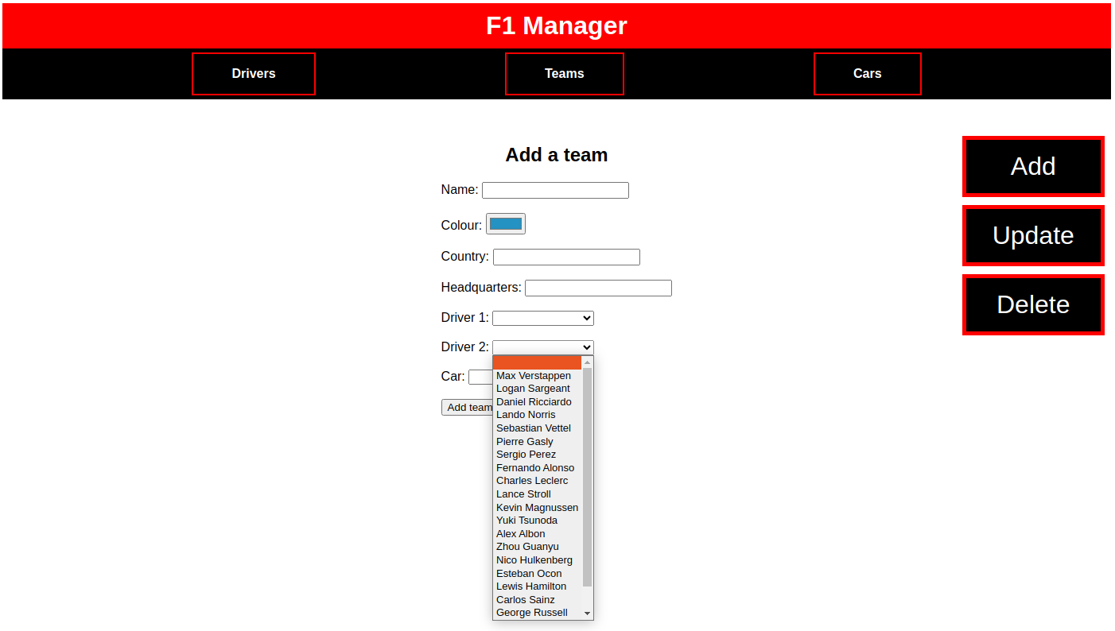
Update:
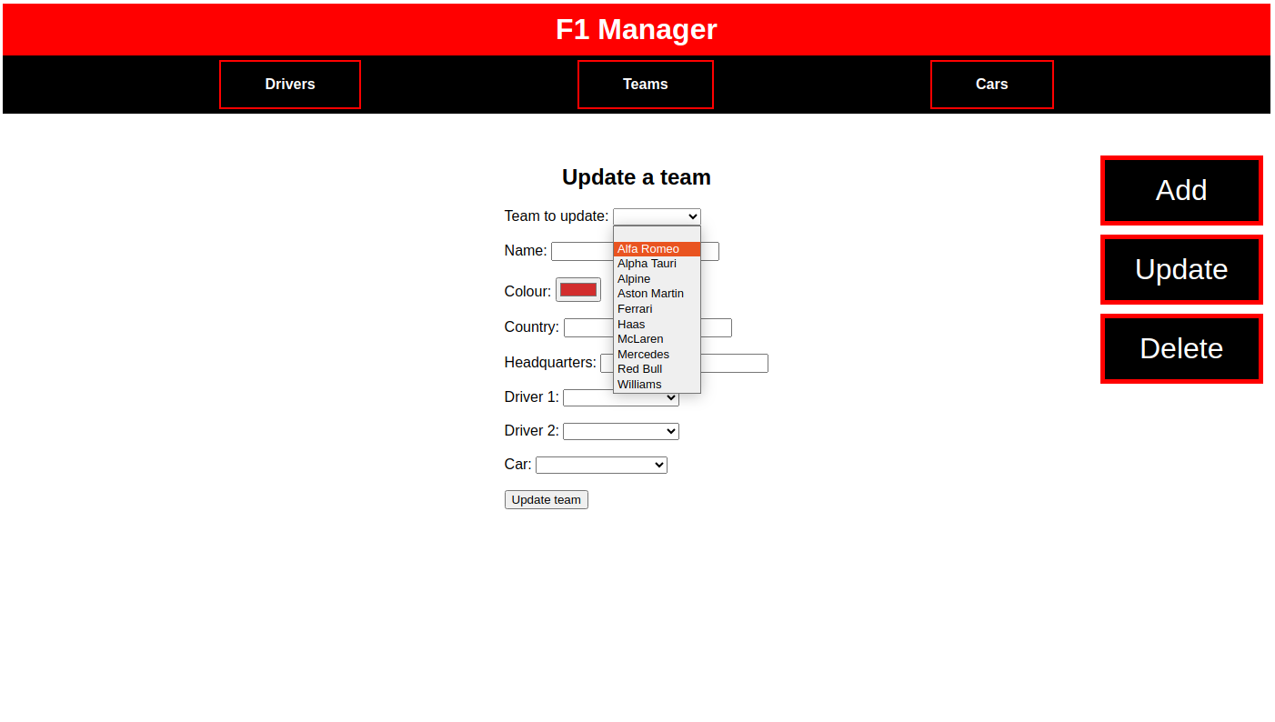
Delete:
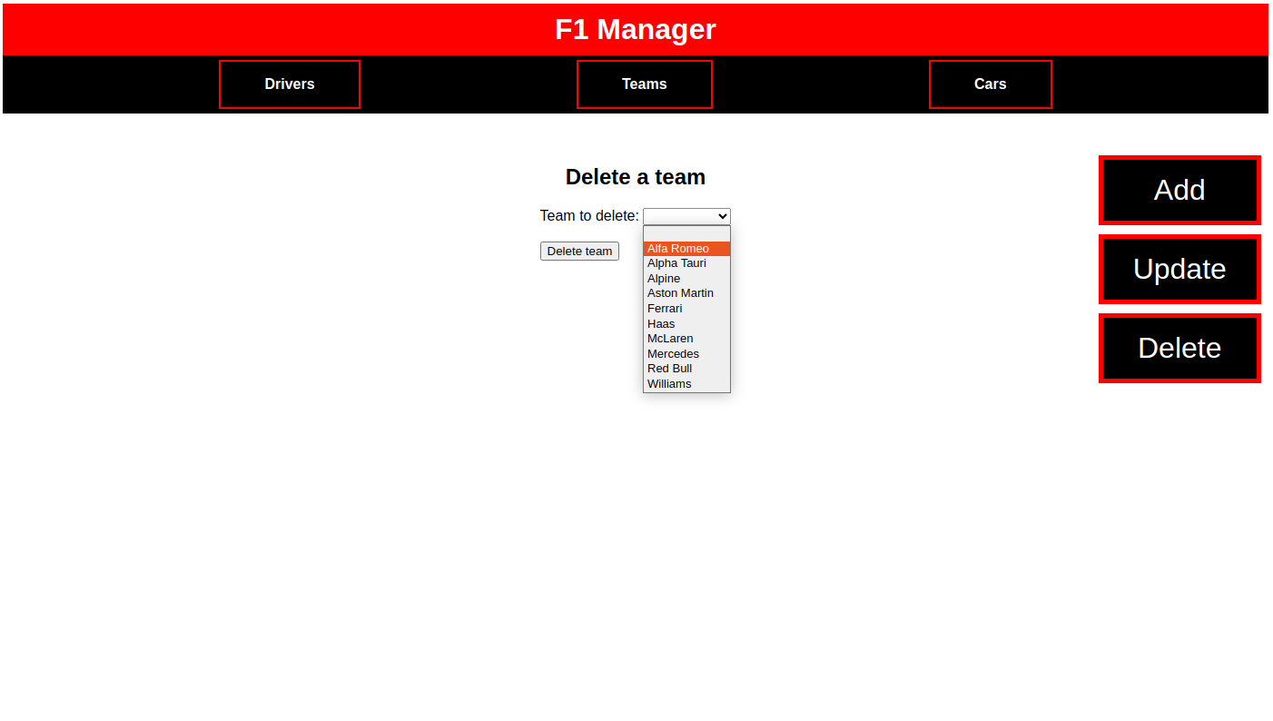

Cars
Display:
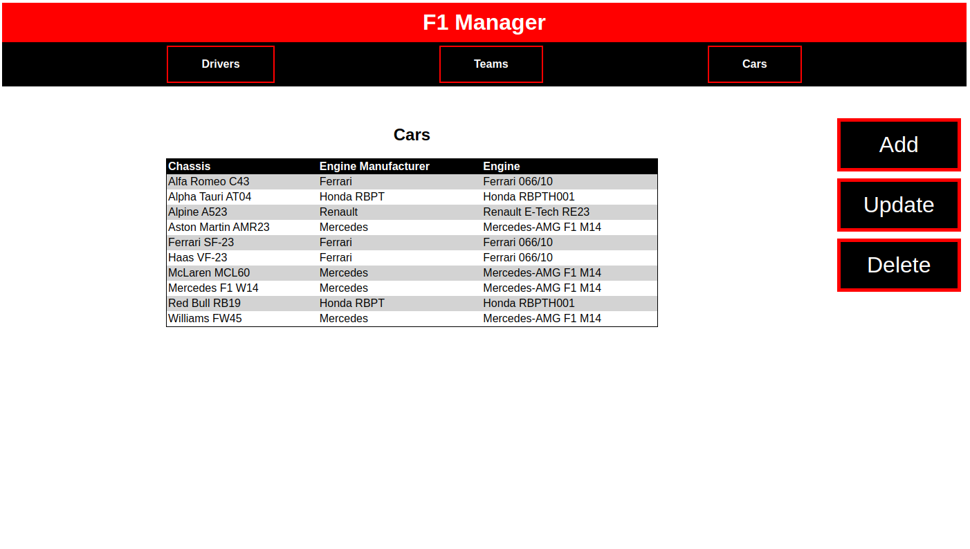
Add:
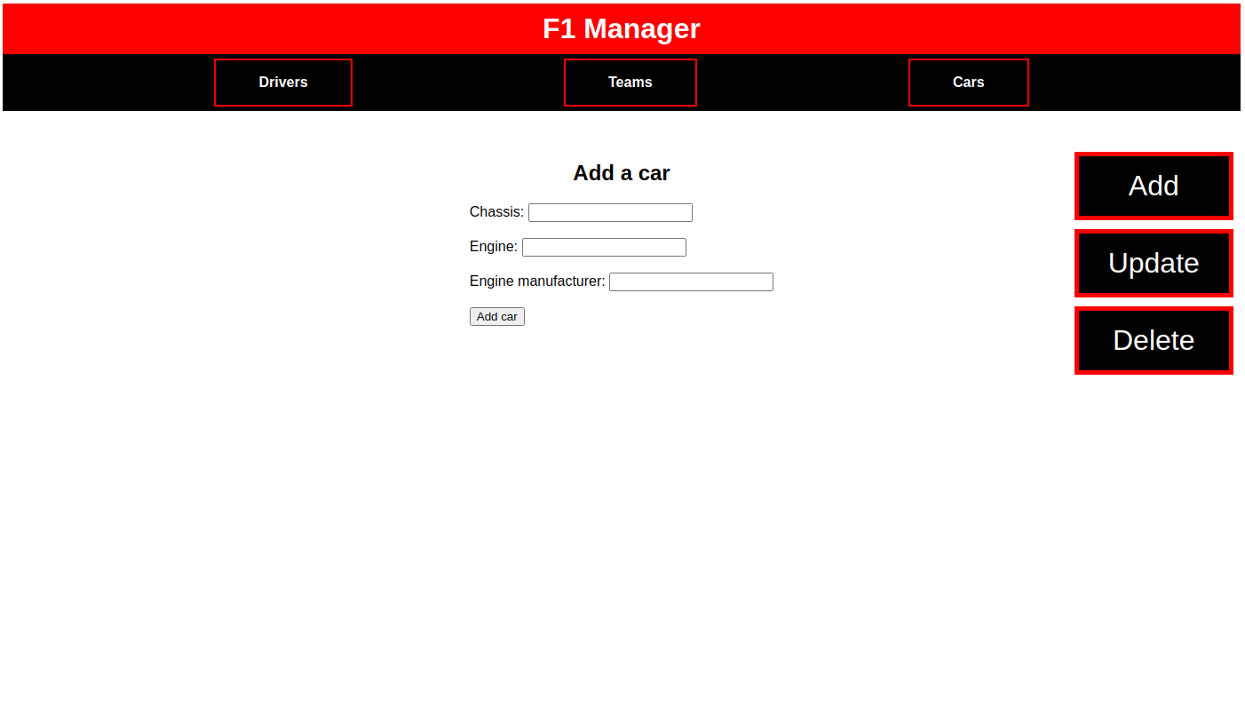
Update:
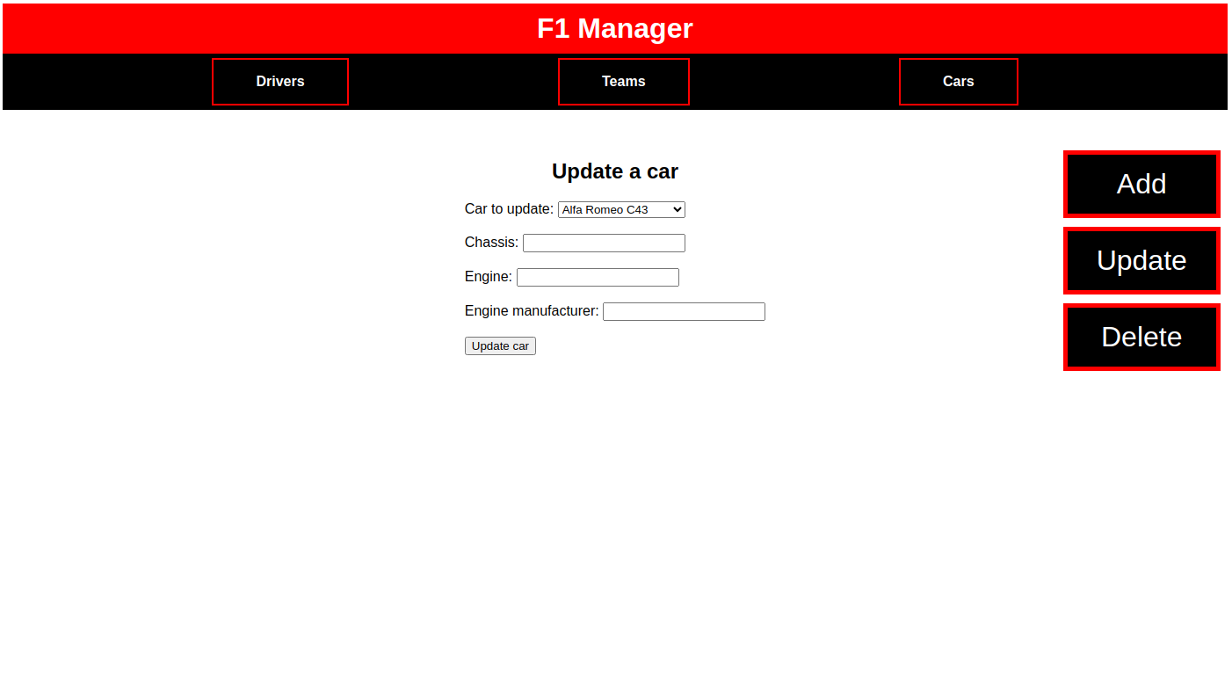
Delete:
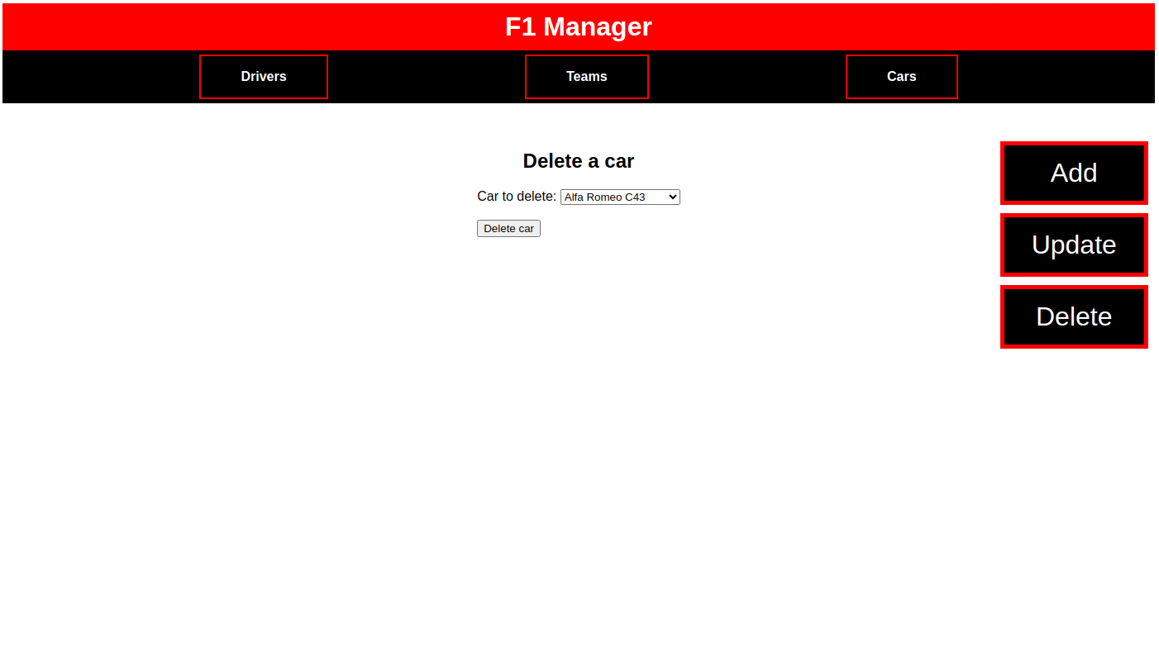

Project score:
- GUI design: aspect, clarity and easy to navigate.
- Originality and innovation
- Complexity
- Clarity, modularization and organization of the code, using comments where necessary.
- Security against possible hacking.
- Error control.

How to submit the project:
You must include:
- pdf file with the design.
- Source files of the application.
Create a .zip with your name and upload it through the corresponding link in "mestre".

